Gordon Elementary School Virtual Learning Introduction:
First Steps:
To turn on your new laptop, press the power button located on the right side.
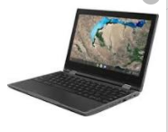
Power Button
Students will log in using their username and password that has been provided by the school.

Each day students will need to check their Outlook e-mail and their Teams Channels to complete work and find correspondence from their teachers.

To check their accounts, students should double-click on the Chrome icon:
Visit www.dillon.k12.sc.us.
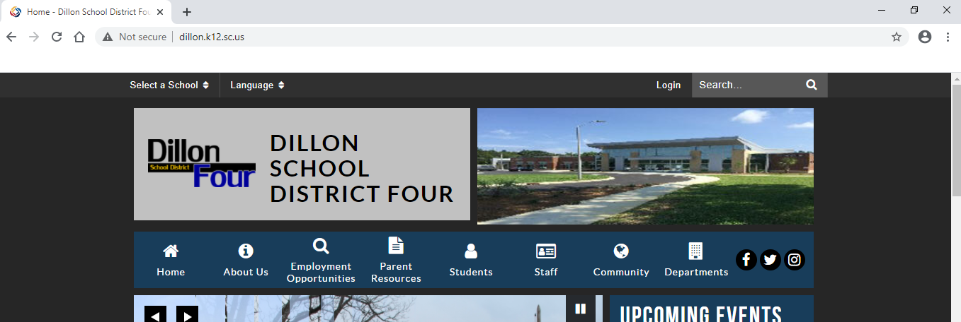

On the District website, click on Office 365.
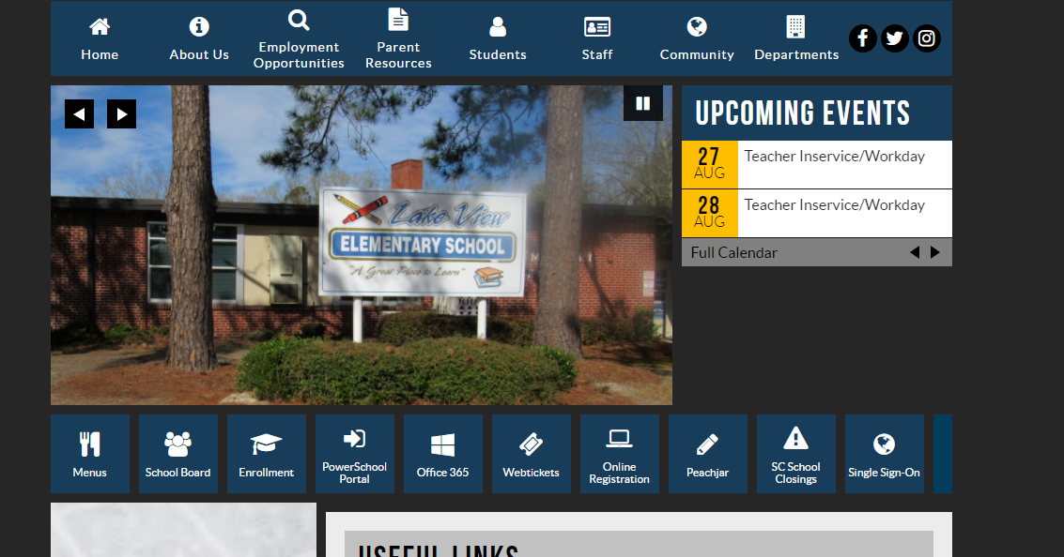

Students will be prompted to login to their Office 365 account. Accounts can be accessed using the student’s login username followed by @dillon.k12.sc.us. Typically this information will already be populated in the Office 365 log in screen.
Students can simply click on their e-mail address.
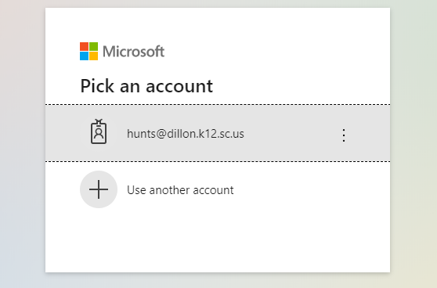
They will then be prompted to enter their password. Their password is the same as the login password for the computer.

To access their e-mail they click on Outlook on the Office 365 site:
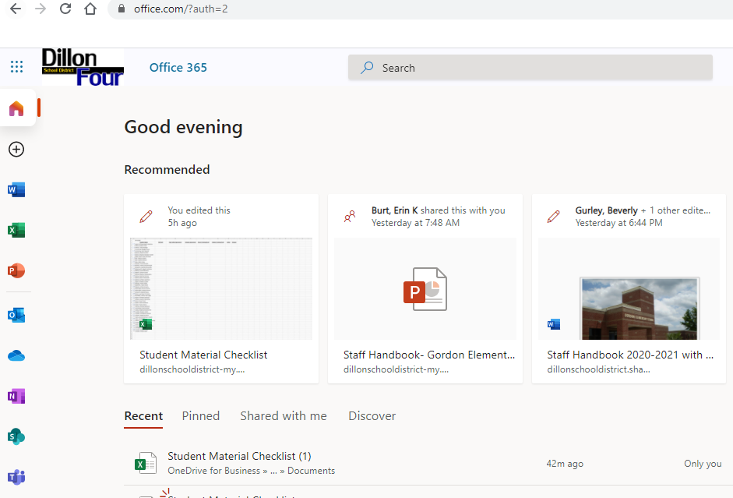

Students can also access Teams from Office 365.
Students will see any team that they are part of by clicking on Teams in the Teams App.
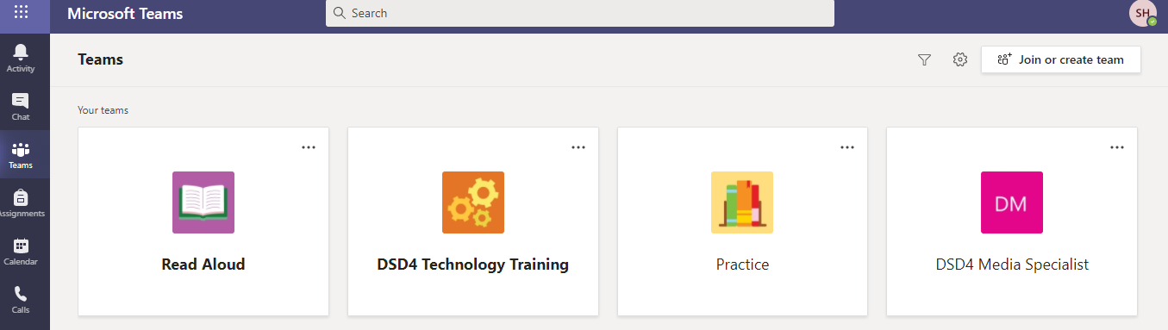
In Teams, students can access lesson videos, assignments, and other content provided by their teacher.
More information about how to use Teams will be forthcoming via e-mail, Teams, and the GES website.
Students can access their e-mail via the desktop app.
First click on the start icon
Then: Scroll down until you see Outlook., Click the icon.
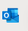
Log in using student username and password. The e-mail address should already populate.

Students should also access Teams using a desktop app.
First click the start icon.
Then scroll down until you see Teams, click the icon.
Students will see any team that they are part of by clicking on Teams in the Teams App.
In Teams, students can access lesson videos, assignments, and other content provided by their teacher.
More information about how to use Teams will be forthcoming via e-mail, Teams, and the GES website.

